**Software Requirements**

**Specification**

**for**

**Smart Student Assistant**

**Version 1.0 approved**

**Prepared by Wenqing Zhao**

**Student Number: 21211886**

**February 12th, 2023**

**Copyright © 2002 by Karl E. Wiegers. Permission is granted to use, modify, and distribute this document.**

**Software Requirements Specification for Smaet Student Assistant Page ii**

# Table of Contents

Table of Contents ii

Revision History ii

1. Introduction 1

1.1 Purpose 1

1.2 Document Conventions 1

2. Overall Description 2

2.1 Product Perspective 2

2.2 Product Features 2

2.3 User Classes and Characteristics 2

2.4 Operating Environment 4

2.5 Design and Implementation Constraints 4

2.6 User Documentation 4

2.7 Assumptions and Dependencies 5

3. External Interface Requirements 4

3.1 User Interfaces 4

4. Other Nonfunctional Requirements 6

4.1 Performance Requirements 6

4.2 Security Requirements 7

4.3 Software Quality Attributes 7

5. Other Requirements 7

# Revision History

|  |  |  |  |
| --- | --- | --- | --- |
| **Name** | **Date** | **Reason For Changes** | **Version** |
| Wenqing Zhao | 12/02/2023 | The first version | 1.0 |

# Introduction

## By reading this document, developers can have a good understanding of the different functional modules to ensure the alignment of requirements with actual results during the development process. This document describes the modules included in the Smart Student Assistant software and explains the logical relationships between them.

## Purpose

## Since everyone's characteristics and experiences are completely different during college life, and it is difficult for the school to provide detailed counseling and care for each student specifically. Therefore, this software provides information services that allow students to get targeted solutions to their problems. Students can benefit from using the software whether it is for studying, exams, or physical or mental health. In addition, it helps students to plan their study schedule so that they don't get overly anxious or indulge themself. I hope that this software will help students to learn more and enrich their lives to make every day meaningful.

## 

## 1.2 Project Scope

Smart Student Assistant is a chatGPT language-processing-based platform to assist students in learning and planning their lives. It intelligently answers students' questions when they have doubts. It also provides access to information such as student calendars and syllabi to provide more personalized advice to students.

When students are confused about something taught in class, they can ask a question in the software and it will connect to chatGPT to search and answer the question. Students can also rely on the software to find free and publicly available teaching resources on the web, such as videos and study notes for each subject. These features can help students solve some not-so-complicated problems and greatly improve their learning efficiency and motivation. With the application of this software, I believe more students will have a clear study plan.

During students' pre-exam review phase, many students are confused about where to start their review. This software can provide a revision plan for each different subject based on the exam date schedule in the student's calendar, so that they are clear about what their study goals are for each day. The software also automatically retrieves previous years' exam questions from the school's website to help students test themselves before the exam. This helps students to get timely revision advice and revision materials that suit their situation. Students are systematically reviewed before the exam, which ensures that they are in a better position to take the exam.

In addition, but the software also cares for students' physical and mental health. Students can ask questions and get quick answers to any health issues they may have.

# 2. Overall Description

## 2.1 Product Perspective

## This is a new, stand-alone product that will provide students with a customised service that most schools cannot provide. This solves a very common problem in college life is that when students have doubts, there is no one to answer them in time. When it comes to the weighting between study and rest, it is difficult for students to design a reasonable study plan independently. So this application provides timely advice for each student's study and health, so that students can get solutions to their problems anytime and anywhere.

## 2.2 Product Features

The student can select one of several modules to view in Smart Student Assistant.

In the Study module, the student can type his question directly into the search box and click on the search button. The search results are returned directly to the page, and a search box is provided at the bottom of the results so that the student can continue to search for an issue that he does not understand. In addition to the search, the software automatically imports the course modules from brightspace and students can select one of the modules to open. All relevant information for the module, such as slides, documents, etc., will be displayed on the page and the student can browse the content. If there is confusion about something in the material, the student can copy it in the search box and this software will return the supplementary information to the current page.

In the Review module, students can select a given module to review or schedule a review. When the student selects a module, the software displays the relevant materials available from the brightspace to browse. Moreover, students can view previous years' questions to test their skills. The review module also allows students to create a review plan based on the calendar and exam date schedule, and students can edit the plan on their own.

## In the Health module, students can ask questions about their mental health issues or physical health issues. They can type the question into the chat box and the software will return the answer in the same box. If the student is still confused about the same question, they can continue to consult on the same page. Moreover, the software can also create fitness plans for students based on their schedules, and students can modify the intensity and duration of their workouts themselves.

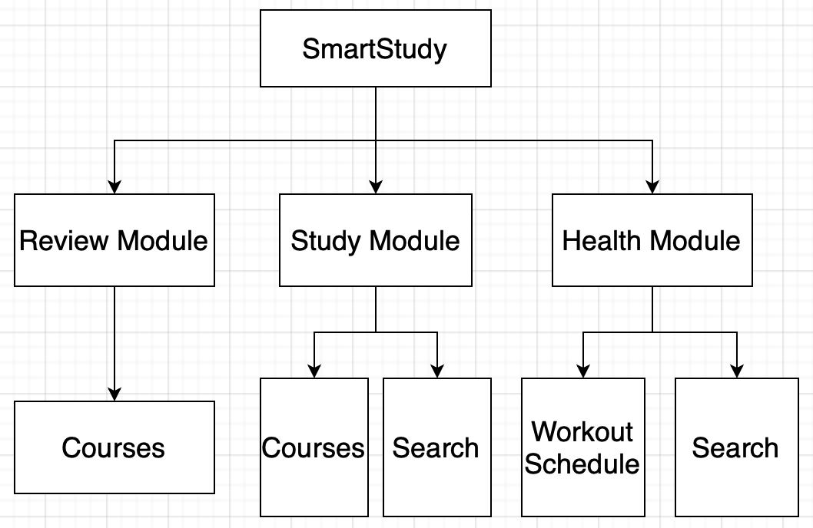

## 2.3 User Classes and Characteristics

Since the software is designed for students only, there is only one user class which is students only.

The requirements for students are that they must be enrolled in college and that they have the ability to search for information. After searching for a solution to the problem, the student has to choose whether to follow the suggestions made by the system or not according to their actual situation.

## 2.4 Operating Environment

## The software is available on all mobile devices, including phones and tablets. It is also required to be connected to the internet at any time during the process to ensure that student information is accessible and to be able to transmit information to chatGPT to obtain the generated results.

## 

## 2.5 Design and Implementation Constraints

## During the development process, it is important to pay attention to the protection of students' personal information, especially the confidentiality of students' account passwords needs to be absolutely guaranteed. Also, since this software transmits information with chatGPT, it is important to filter the content of the information before transmission to ensure that students' private information is not leaked.

## In addition, since chatGPT's website may have the possibility of temporary crashes, when the system cannot get a response from chatGPT for a long time, end the wait for the current session and inform the student that there is a latency on the current server and please try again later.

## 2.6 User Documentation

User manuals will be delivered with the software

## 

## 2.7 Assumptions and Dependencies

# The software needs to be used on a mobile device with sufficient performance requirements. If the mobile performance is too low, such as the device memory is below the threshold or CPU performance is too low or the system version is too old to support. These conditions will cause the software to freeze and crash, causing the software to fail to run. In some cases, it can also lead to file loss.

# The software needs to be connected to the Internet during the whole process, when the device can not connect to the Internet will lead to failure to obtain student information, can not search operations and other problems.

# 3. External Interface Requirements

## 3.1 User Interfaces

When the student opens the software, the following screen should be displayed:

The calendar shows the student's course schedule and exam schedule. There are three buttons placed at the bottom of the page that link to other modules.

## Screenshot 2023-02-12 at 21.20.18

When the Review or Study module is opened, a search box is displayed at the top of the page, and the names of the courses are listed below

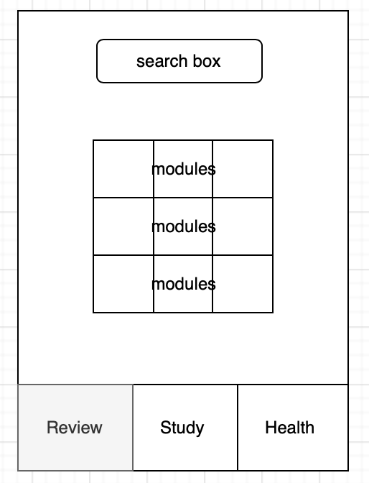 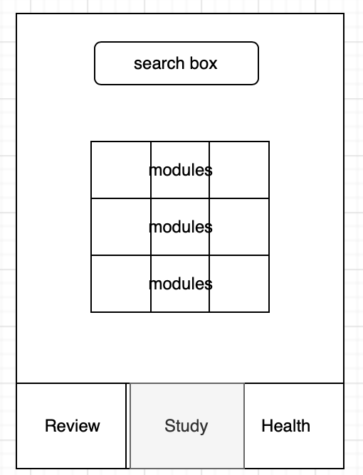

In the health module, the search box is at the top and the fitness plan is at the bottom

# Screenshot 2023-02-12 at 21.30.15

# 4. Other Nonfunctional Requirements

## 4.1 Performance Requirements

## The software is designed to be a light-weight application, so it should not be larger than 300MB and should occupy a small amount of memory during its running. Since the software does not require a lot of local processing or calculations, it should have low performance requirements for mobile devices and be adapted to older models and system versions as much as possible. The software needs to be adapted to devices of different sizes and resolutions, so it is also recommended to use adaptive layout development to ensure uniformity of its display.

## 4.2 Security Requirements

## This software requires students to enter their account numbers and passwords when obtaining information from the school's official website, so it is necessary to use encryption for this important data and a more secure way to transmit the information. When transmitting data from the software to chatGPT, the information is checked to ensure that it does not contain personal information of the student before sending it out.

## 4.3 Software Quality Attributes

# The software was developed with maintainability in mind to minimize maintenance costs. Since the purpose of this software is to solve unanswered questions that arise in students' learning and life, the use of this software needs to be ensured to be simple and clear to avoid complicated process of using the software.

# 5. Other Requirements

This software must be developed and used within the limits of law and morality, and must not be used to communicate illegal information or for illegal profits. During the development process, the developer must be careful not to contradict the rules and regulations of chatGPT and the university's website, and not to obtain information or execute operations other than those allowed.